**Assignment 3**

• Use the Employee Details dataset and perform the following activities: -

* Split the column CITY and separate the code associate with each city like - Allahabad [AL2] should be only Allahabad and [A2] will be separate.

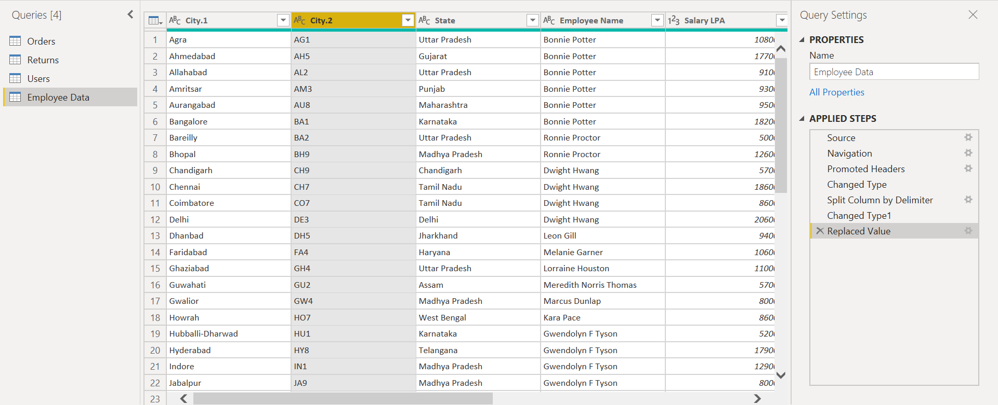

* Extract the first name from EMPLOYEE NAME column and transform the column.

1. Using Transform🡪Extract function-

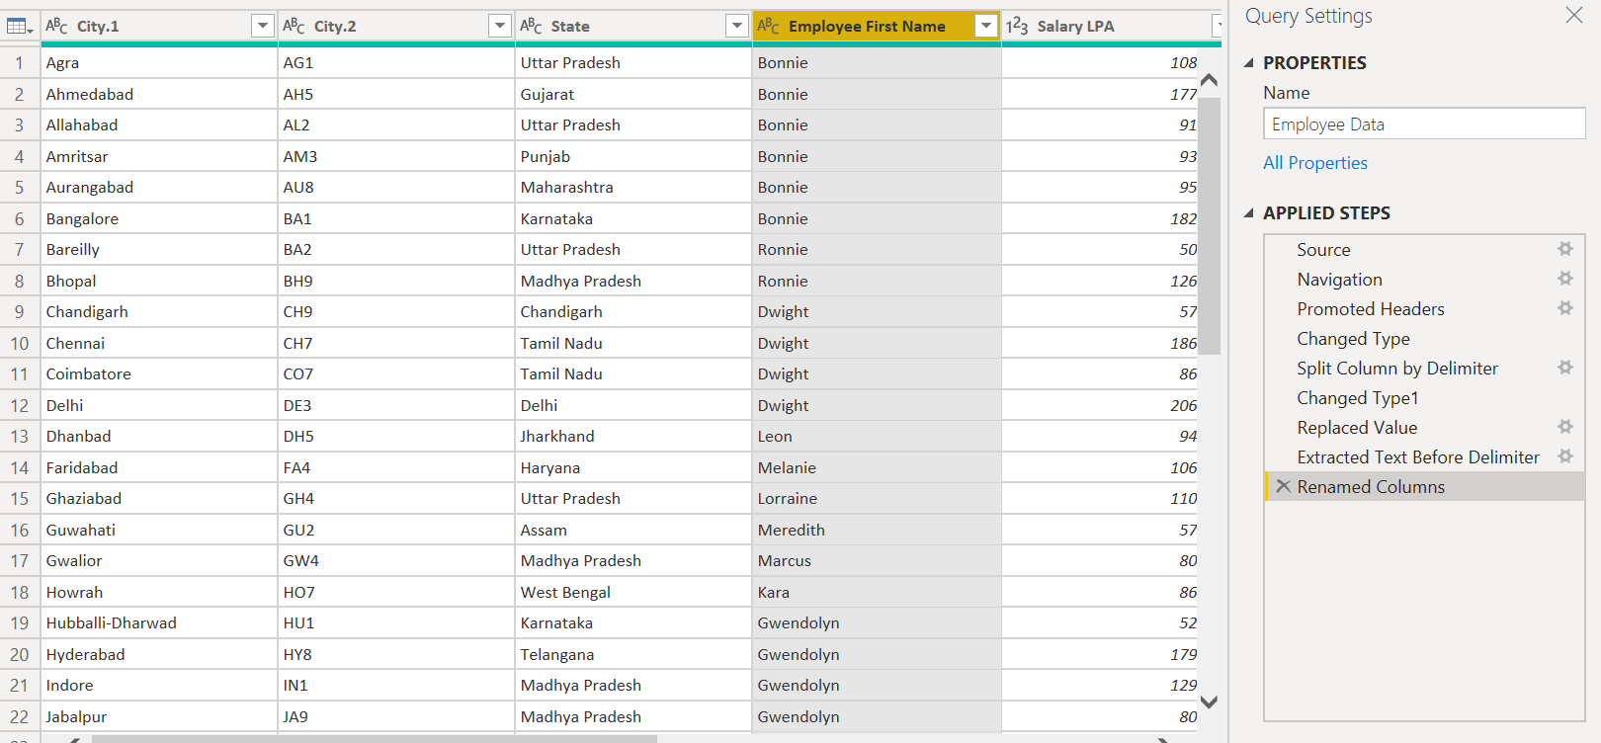

1. Using Split Column function -

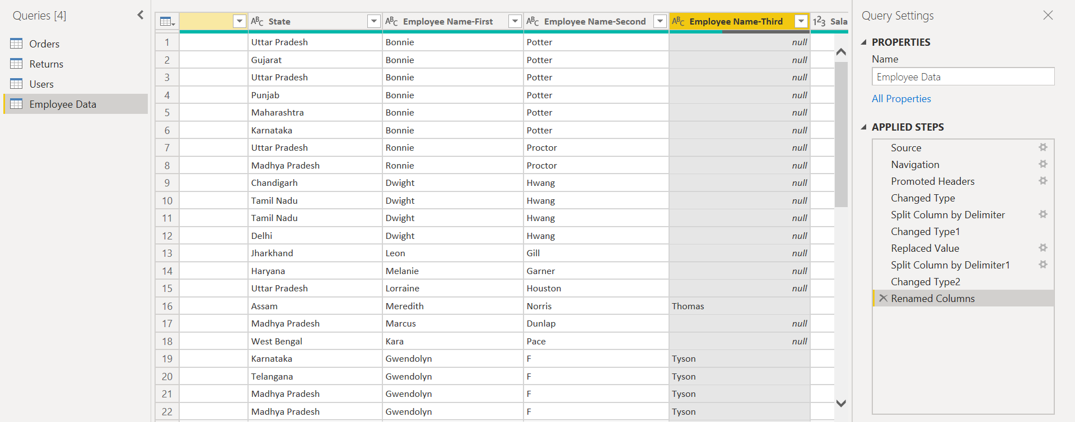

* Using the JOINING DATE column extract the Year and no. of days for that month.

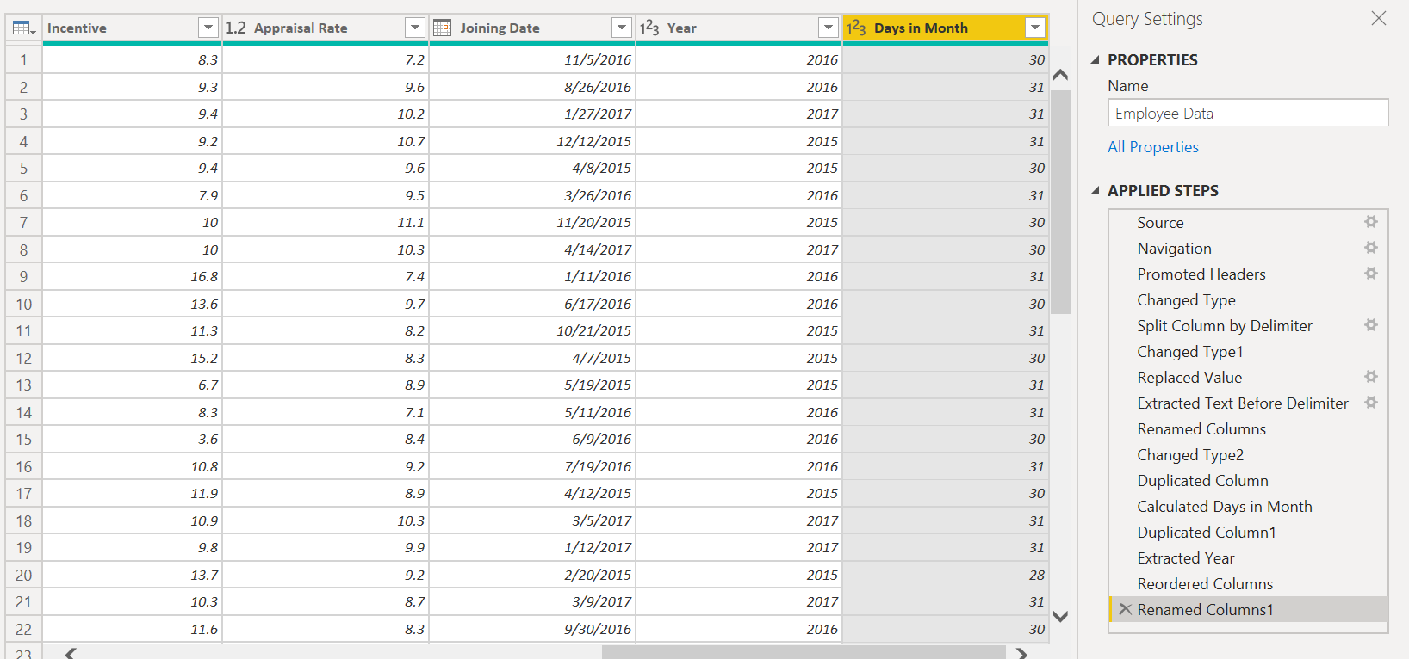

* Create a visual of your choice and show the how much salary has been paid to each state and which state has lowest payout.

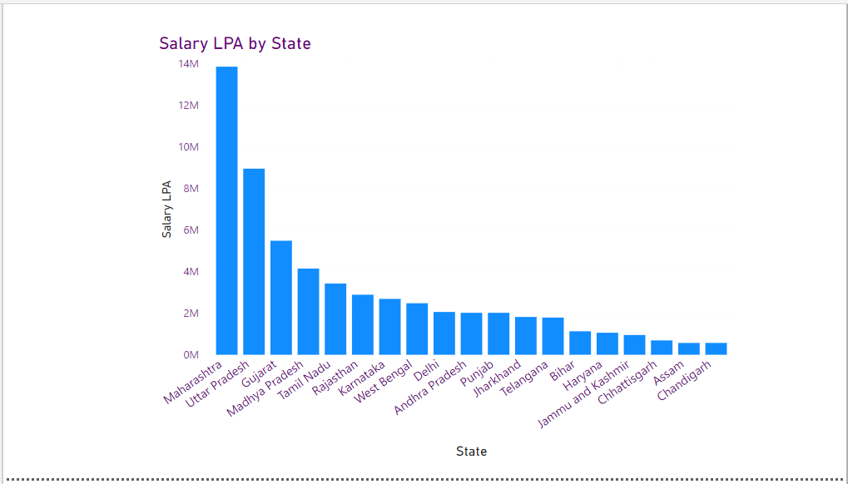

Here Chandigarh is showing the lowest payout.

